ITA0510 COMPUTER VISION
LAB ACTIVITY:
1)Perform basic Image Handling and processing operations on the image.
Aim: Read an image in python and Convert an Image to Grayscale
Algorithm:
- Import the required OpenCV library.
- Read the input image from the specified file path using cv2.imread().
- Display the original image.
- Convert the original image to grayscale using cv2.cvtColor() with the COLOR_BGR2GRAY conversion flag.
- Display the grayscale image.
- Save the grayscale image using cv2.imwrite().
- End the program.
CODE:
import cv2
from google.colab.patches import cv2_imshow
img = cv2.imread("/content/yu-chin-tsai-piTEABtlR1Q-unsplash.jpg")
gray_img = cv2.cvtColor(img, cv2.COLOR_BGR2GRAY)
print("Grayscale Image")
cv2_imshow(gray_img)
INPUT:
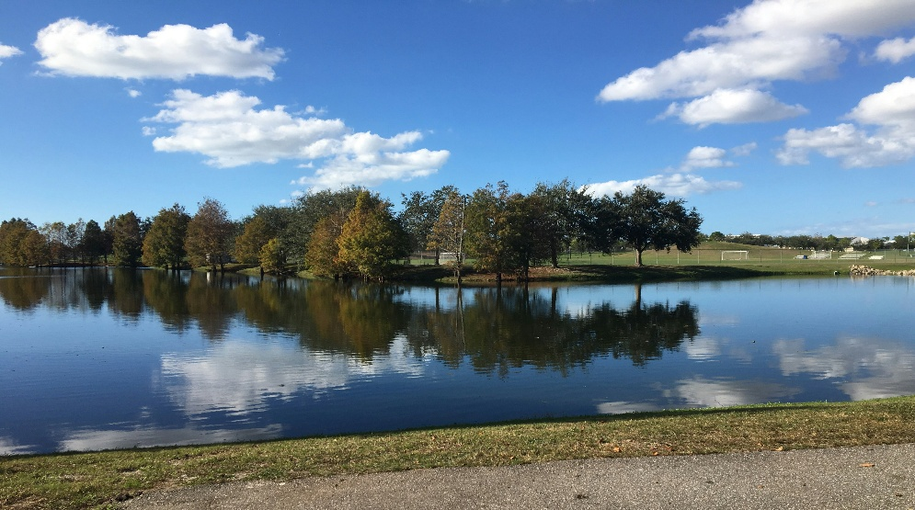
OUTPUT:
Grayscale Image
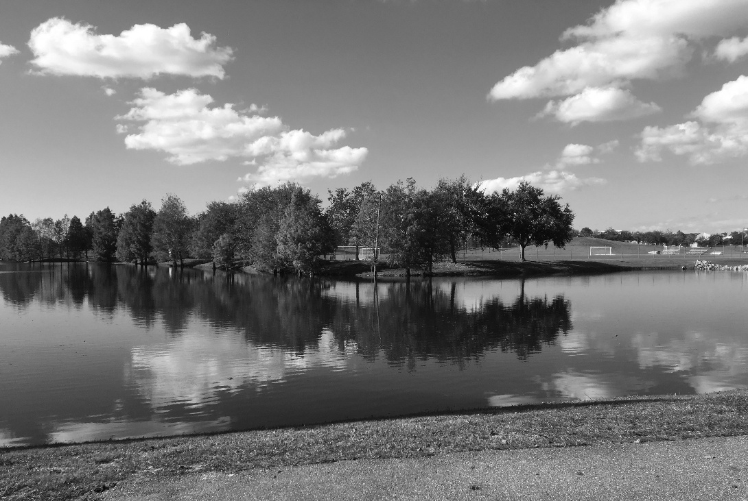
RESULT: Thus the program is executed successfully.

2) Perform basic Image Handling and processing operations on the image
Aim: Read an image in python and Convert an Image to Blur using
GaussianBlur.
Algorithm
- Import the required libraries (cv2 and cv2_imshow).
- Read the input image from the specified file path using cv2.imread().
- Apply Gaussian Blur to the image using cv2.GaussianBlur() with a kernel size of (5, 5).
- Print a message indicating that the blurred image is being displayed.
- Display the blurred image using cv2_imshow().
- End the program.
CODE:
import cv2
from google.colab.patches import cv2_imshow
img = cv2.imread("/content/yu-chin-tsai-piTEABtlR1Q-unsplash.jpg")
blur_img = cv2.GaussianBlur(img, (5, 5), 0)
print("Blurred Image")
cv2_imshow(blur_img)
INPUT:
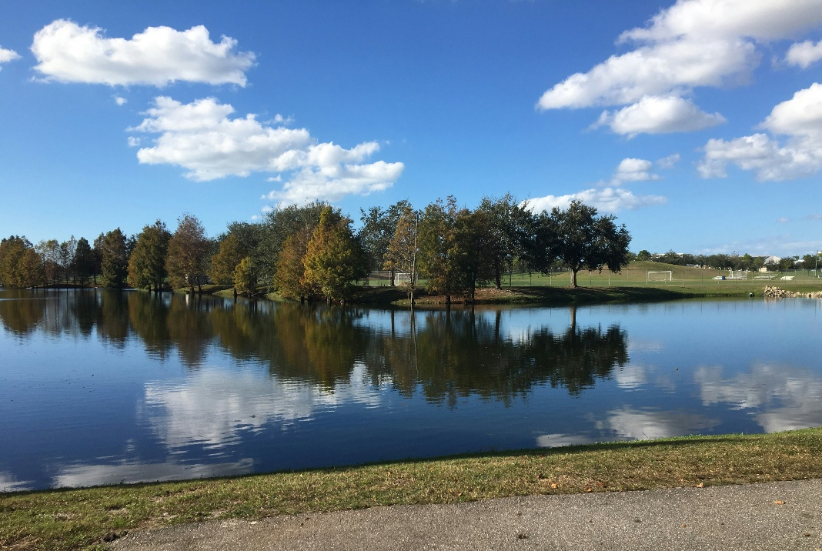
OUTPUT:
Blurred Image
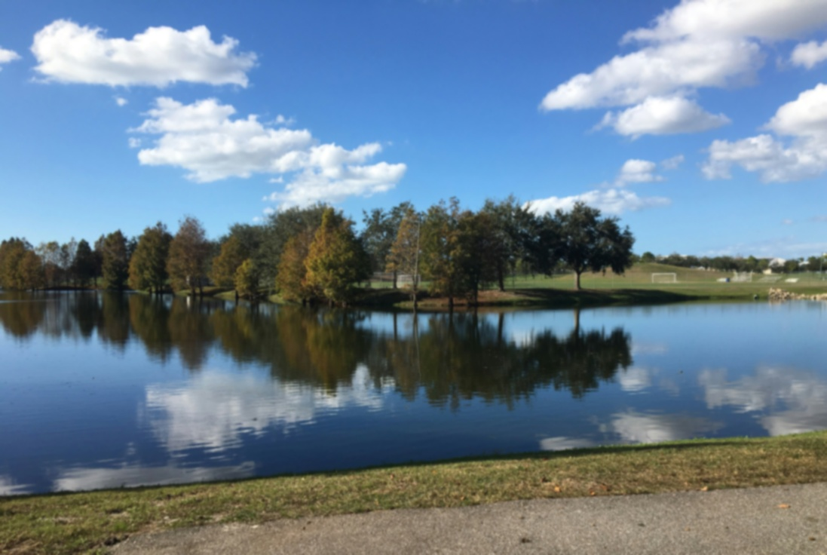
RESULT: Thus the program is executed successfully.

3) Perform basic Image Handling and processing operations on the image
Aim: Read an image in python and Convert an Image to show outline using Canny function.
Algorithm
- Import the required libraries (cv2 and cv2_imshow).
- Read the input image using cv2.imread().
- Convert the color image into a grayscale image using cv2.cvtColor().
- Apply the Canny edge detection algorithm using cv2.Canny().
- Display the detected outline (edge) image using cv2_imshow().
- End the program.
CODE:
import cv2
from google.colab.patches import cv2_imshow
img = cv2.imread("/content/yu-chin-tsai-piTEABtlR1Q-unsplash.jpg")
gray_img = cv2.cvtColor(img, cv2.COLOR_BGR2GRAY)
edges = cv2.Canny(gray_img, 100, 200)
print("Outline using Canny Edge Detection")
cv2_imshow(edges)
INPUT:
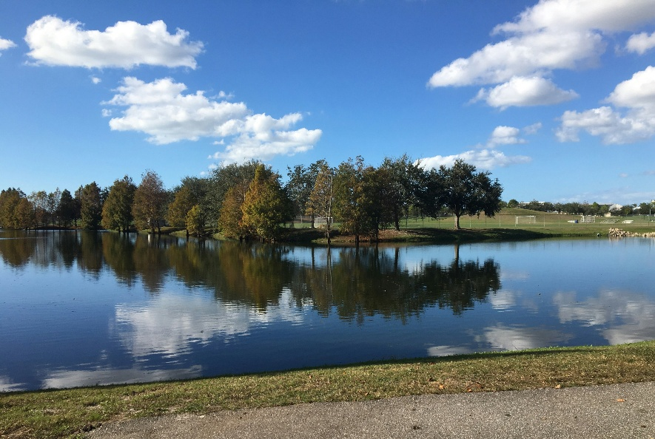
OUTPUT:
Outline using Canny Edge Detection
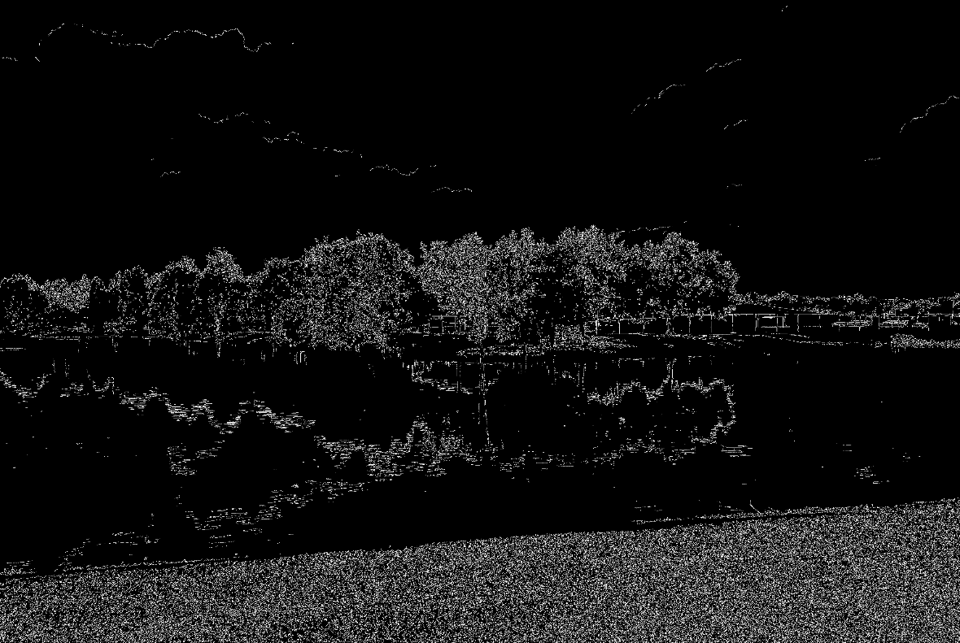
RESULT: Thus the program is executed successfully.

4) Perform basic Image Handling and processing operations on the image
Aim: Read an image in python and Dilate an Image using Dilate function.
Algorithm
- Import the required libraries (cv2, numpy, and cv2_imshow).
- Read the input image using cv2.imread().
- Create a structuring element (kernel) using NumPy.
- Apply the dilation operation using the cv2.dilate() function.
- Display the dilated image using cv2_imshow().
- End the program.
CODE:
import cv2
import numpy as np
from google.colab.patches import cv2_imshow
img = cv2.imread("/content/yu-chin-tsai-piTEABtlR1Q-unsplash.jpg")
kernel = np.ones((5,5), np.uint8)
dilated_img = cv2.dilate(img, kernel, iterations=3)
print("Dilated Image")
cv2_imshow(dilated_img)
INPUT:

OUTPUT:
Dilated Image
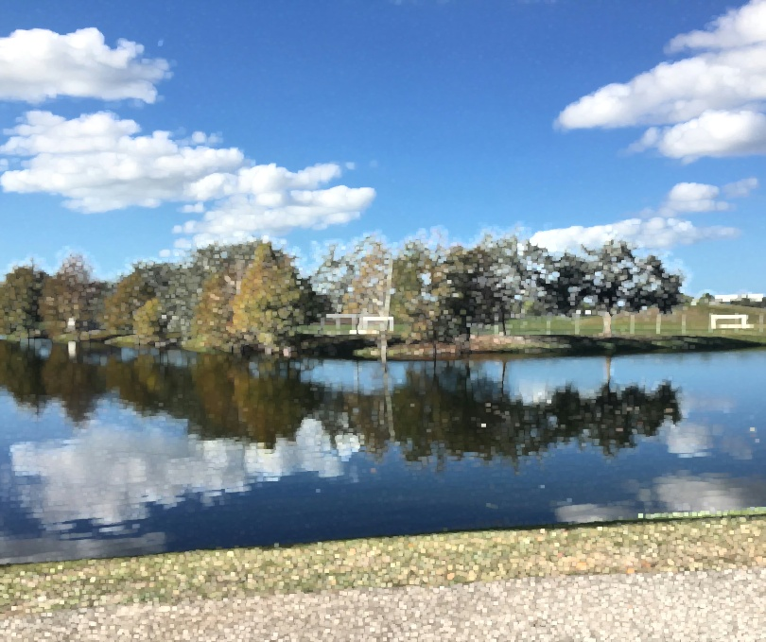
RESULT: Thus the program is executed successfully.

5. Perform basic Image Handling and processing operations on the image
AIM: Read an image in python and Erode an Image using erode function
Algorithm
- Import the required libraries (cv2, numpy, and cv2_imshow).
- Read the input image using cv2.imread().
- Create a structuring element (kernel) using NumPy.
- Apply the erosion operation using the cv2.erode() function.
- Display the eroded image using cv2_imshow().
- End the program.
CODE:
import cv2
import numpy as np
from google.colab.patches import cv2_imshow
img = cv2.imread("/content/yu-chin-tsai-piTEABtlR1Q-unsplash.jpg")
kernel = np.ones((5,5), np.uint8)
eroded_img = cv2.erode(img, kernel, iterations=3)
print("Eroded Image")
cv2_imshow(eroded_img)
INPUT:

OUTPUT:
Eroded Image
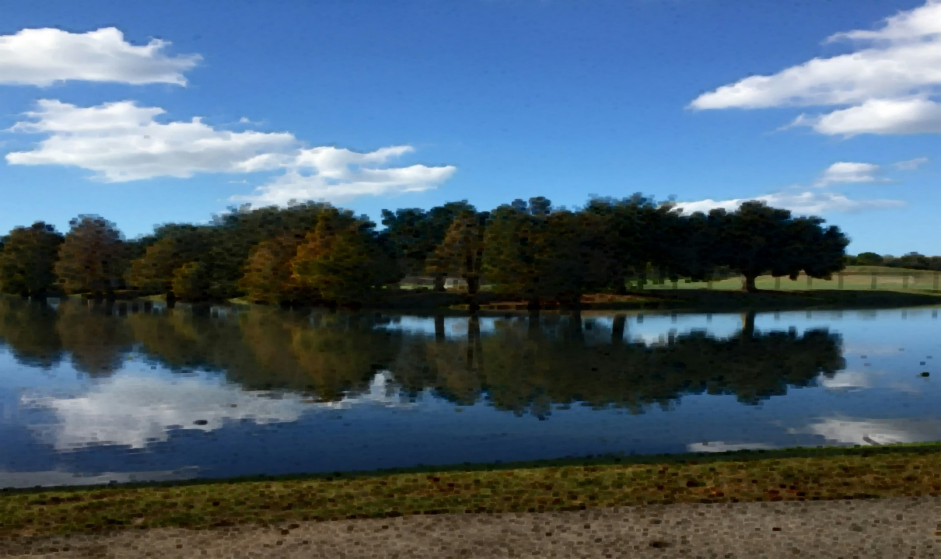
RESULT: Thus the program is executed successfully.

